Differential Gene Expression Analysis Platform

Instructions Manual

  - “Developing a Differential Gene Expression (DGE) Analysis Platform for continuous use by Researchers”

Table of Contents
Document Revision History 3
Preliminary Accessibility 4
Platform and Server Guide 5
Server Setup 5
Navigate to the DGEAP Directory 5
Running the Singularity Image 5
Getting Started 6
Connecting to the Webpage 6
Using the Application 6
Uploading Files 6
Setting Parameters 7
Analysis Load Screen 7
Output Display 7
Appendix 8
A. Webpages 8

Document Revision History
Version | Date | Description | Notes
1.0 | May 31, 2022 | Detailing Instructions for using and running the platform | N/A

Preliminary Accessibility
Due to the nature of the project, the DGEAP code is hosted on the OSU Engineering Server and tracked through a GitHub Repository. To have access to the code, the user must have access to the Engineering Directory where it is located or the GitHub Repository. For the user to run the project, currently located on the Engineering Server, the user must have access to the OSU Network. This can be accomplished by connecting to an OSU-Owned Internet connection or connecting to the OSU VPN Service.

Platform and Server Guide
If the platform has already been setup, then the user may continue to the section “Getting Started,” otherwise continue reading for information on how to initialize the DGEAP container and server.

Server Setup

Navigate to the DGEAP Directory
- Open a command prompt window
- Enter the command:
ssh ONIDuser@access.engr.oregonstate.edu
  - Login with username and password, and DUO
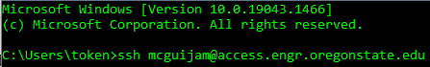
- Once you are logged in, you will see a new instance started
- Enter the command:
cd /nfs/guille/eecs_projects/capstone/old/DGEAP
- Your directory should now be within this folder, as such:

Running the Singularity Image
- In the DGEAP directory, run the following command:
singularity run --bind $PWD image.sif
  - You will be put into a new instance inside the image
- Navigate to the webapp folder with the follow command:
cd DGEAP/webapp
- Enter the command:
gunicorn --workers=3 --threads=2 --bind 0.0.0.0:xxxx wsgi:app

Getting Started
Once the server is running, users may freely open the webpage and begin using the application. Depending on when the server was last started, the web URL may differ from previous connections due to a change in Port number. If the Port number has changed, consult the last user to start the application, or optionally restart the server.

Connecting to the Webpage
- Connect to an OSU Network
  - Using the OSU VPN Service
  - Using an OSU Internet Connection
- Open a Preferred Web-Browser and go to the application URL
  - URL Template with (PORT-NUMBER) referenced earlier:
http://flip.engr.oregonstate.edu:(PORT-NUMBER)/
  - Example URL (PORT-NUMBER) = 1234:
http://flip.engr.oregonstate.edu:1234/

Using the Application
Upon successfully navigating to the URL, users are presented the Welcome Page of DGEAP, Appendix A.1. Here, users can select “Get Started” – where they will then be directed to the Uploads Page, or navigate to Batch Correction tab and/or the Analysis tab if they have already uploaded files to the server.

Uploading Files
On the Uploads Page, Appendix A.2, users may choose (or drag and drop) files for the relevant upload boxes displayed.
- Select “Upload Files” for required boxes
  - Optionally, upload Filter and Config Files
- Navigate to the file that corresponds to the box name you are uploading to
- Select the corresponding file
  - I.e Do not choose a Coldata file for the Counts box
- Wait for the upload progress bar below its name to fill up
  - It will become a darker shade of green indicating it is complete
- Repeat the process for the required files and any optional files
- Double Check the appropriate files are uploaded to the correct boxes
- Select “Next: Parameters”

Setting Parameters
The Parameters page, Appendix A.3, allows the user to set thresholds and names that correspond to the gene column data.
- Select the appropriate Analysis Type you are conducting
- Enter appropriate parameter values into the text boxes that appear
  - If the user has uploaded a Config file, the values entered in the file will be populated in these text boxes
- Check to make sure the parameters have been entered correctly
- Select “Submit”
- Check the desired analysis is being performed from the pop-up message
- Select “Run Analysis”

Analysis Load Screen
Once the Analysis has begun, the user is presented with a loading screen as it is calculating. For diagnostic purposes, the user may open the drop-down menu that displays the Analysis output from the terminal session it is running in. This will display to the user what is happening in the R code, and any output that is displayed from it. In the unlikely circumstance that the analysis is failing, the terminal code may be used to diagnose the error in either the user’s data itself (if R is having trouble processing strings or numbers) or if there is an unknown error caused by the input files. Users may ignore this drop-down unless they are waiting an unreasonable amount of time, such as 10+ minutes, for their data to process. This may change depending on input file sizes.

Output Display
The Application will redirect the user to the Display Page, Appendix A.4, where a lot of options for reviewing the analysis output are available. On this page, users may:
- display unfiltered/filtered analysis results
- sort by column values and name
- find specific genes by name
- view various plots of the results
- download the unfiltered/filtered analysis results
- change parameters to conduct a new analysis
- change input files to conduct a new analysis

Appendix
- Webpages
  - Welcome Page
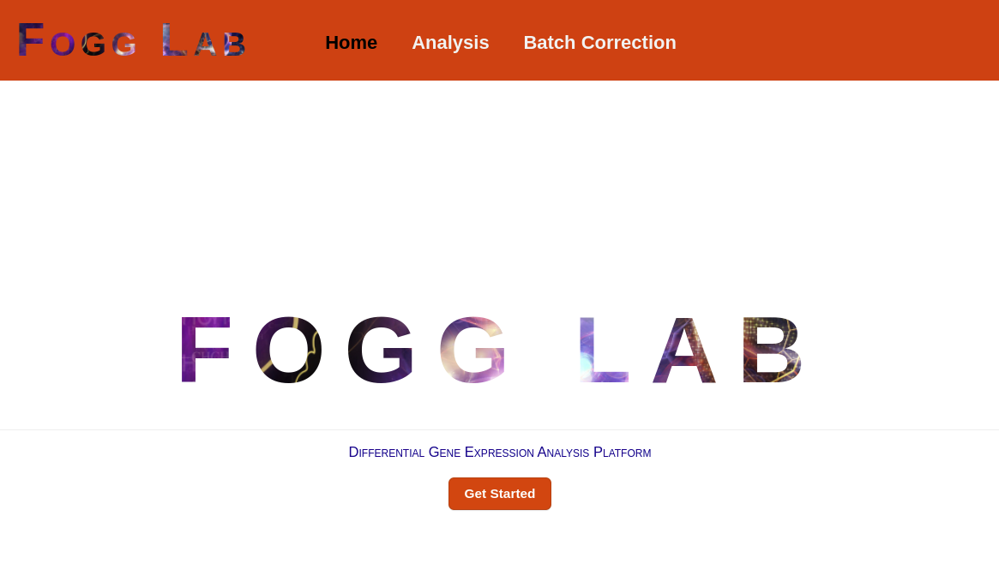
  - Uploads Page
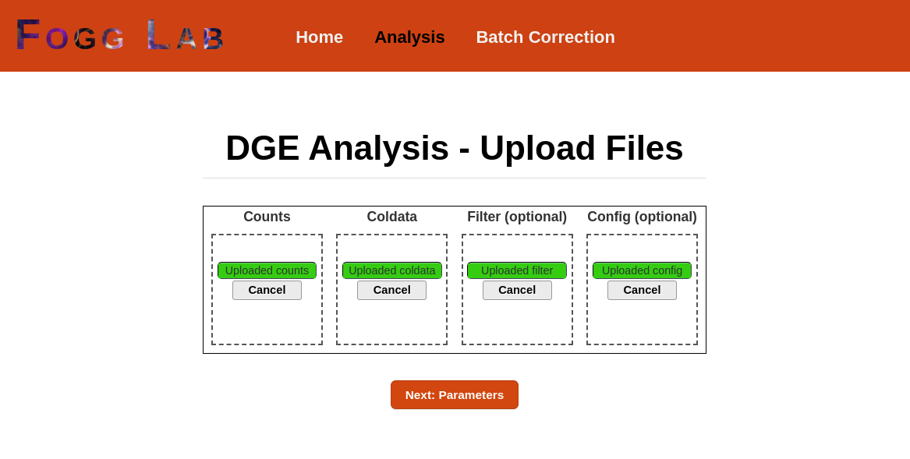
  - Parameters Page
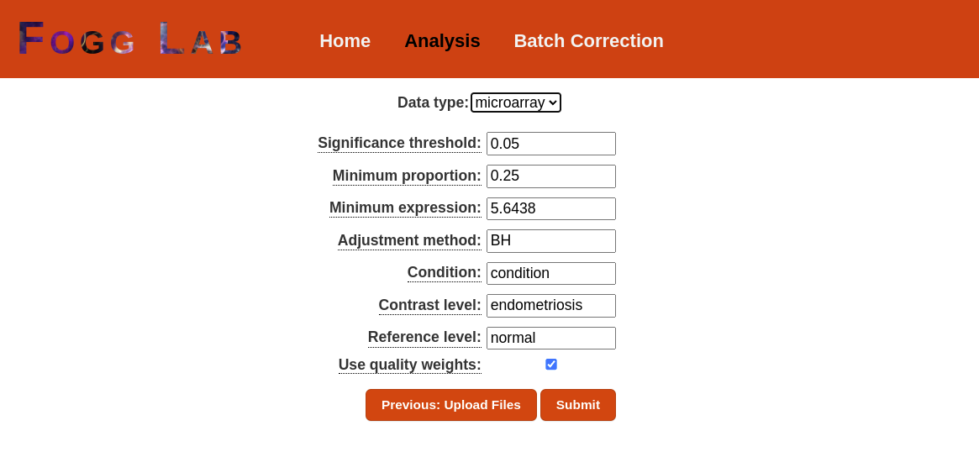
  - Display Page
